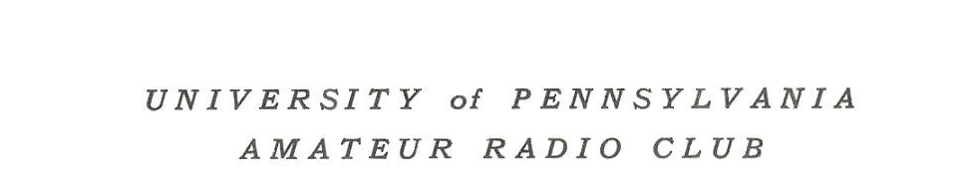
Minutes of the Amateur Radio Club

University of Pennsylvania
Philadelphia, PA 19104

https://w3abt.seas.upenn.edu/

Planning Meeting: Thursday, September 26, 2019 at Houston Hall on the Campus of the University of Pennsylvania, Philadelphia, PA.

Attendees:

John Campbell, Devin Carroll, Russ Miller, Evan Oskierko-Jeznacki

Welcome

Russ Miller called the meeting to order at 10:00 AM and welcomed everyone. Russ also noted that the Club first met in Houston Hall in 1909 and our 110th anniversary will occur on Friday, October 4, 2019.

Elections

Sarah Friedensen was nominated for the role of President for the 2019 - 2020 school year. No other nominations were received. A motion was made and seconded to approve Sarah's election. The vote was unanimous.

Student Membership Drive

A discussion took place regarding ideas to increase the club’s presence with the student membership and to recruit new student members. In order to attract new students, there need to be activities of interest. It was suggested that we also need to identify classes, such as Signal and Information Processing - ESE 224 where students could use the knowledge gained in class and apply it to practical applications. It was decided that Nik Sultana and Devin Carroll would be excellent guides to develop a pathway of classes that parallel the Club's focus.

It was also agreed that students would be attracted to one to two hour meetings that are devoted to construction projects. Teaching students skills such as how to solder electronic components and build simple kits seem appropriate. Public Safety projects such as the long dormant D-STAR installation at HUP were also discussed. It was decided that John Campbell would investigate the status of the D-STAR project.

Club Station

One of the chief reasons for the Club's decline has been the lack of an operating radio station. When the Club's HF antenna was not replaced in 2014, there were no activities. Evan Oskierko-Jeznacki has agreed to look into possible locations for a new Club station.

With no further business, the meeting was concluded at 10:32 AM.

Minutes prepared and submitted by:
Russ Miller, Alumni Liaison

MeetingMinutes09262019.doc

